**UCLA ENG 111 Winter 2018 Mel Bulu-Taciroglu**

**FINAL SOLUTIONS**

**Multiple Choice Questions (3 points each)**

**1.** Agency problem arises whenever:

1. the owner of a company also acts as the manager.
2. a takeover threat materializes.
3. there is misalignment of interests.
4. A and C
5. A, B, and C

**2.** Consider two projects with the following cash flow:

|  |  |  |
| --- | --- | --- |
| Year | Project A | Project B |
| 1 | 1,000 | 3,000 |
| 2 | 1,000 | 1,000 |
| 3 | *x* | 1,000 |

Which of the following is **true** concerning these two projects?

1. If interest rate is 10%, Project A has a higher NPV for any *x* greater than 3,000.
2. Regardless of the rate, project B is STRICTLY MORE valuable if *x* = 3,000.
3. Regardless of the value of *x,* if the payback period method accepts Project B, it would also accept Project A.
4. Regardless of the value of *x,* if the payback period method accepts Project A, it would also accept Project B.
5. None of the above.

**3.** You purchased a 10-year bond exactly one year ago at its face value. The Current yield on the bond went down from last year to this year. Then, it must be the case that

1. Market rate went up from last year to this year.
2. Market rate went down from last year to this year.
3. The market rate stayed the same but there is less time left until maturity.
4. Capital gains yield is higher than yield to maturity.
5. None of the above.

**4.** Scenario analysis refers to?

1. finding the NPV of a project under the assumptions of different possible future costs.
2. considering different NPVs of a project under the assumption of different possible future values of the revenue the project will bring.
3. fixing a certain realization of the future and adjusting the interest rate by keeping all other variables of the project constant.
4. fixing a certain realization of the future constant and finding the financial break-even points by considering different interest rates.
5. fixing a certain possible realization of the future and adjusting all the variables of the project accordingly to find the corresponding NPV.

**5.** Market rate is 10%. Café Commissary has an internal growth rate of 2.46%, retention ratio of 40%, and debt to equity ratio of 1. If Commissary has a Net Income of 240,

1. Commissary has a sustainable growth rate lower than 2.46%.
2. Commissary has more short term debt than long term debt.
3. Increasing retention ratio will increase Commissary’s stock price.
4. If Commissary wants to grow at 5%, it will have a positive external financing need.
5. none of the above.

**6.** You are analyzing two mutually exclusive projects using the following data,

|  |  |  |
| --- | --- | --- |
|  | Project A | Project B |
| Initial Cost | 2,000 | 3,000 |
| Annual Revenue | 650 | 850 |
| Life of the Project | 5 years | 5 years |

You are asked for your best recommendation given the above information. Market rate is 10%. Your recommendation should be:

1. Accept Project B since it has a shorter payback period.
2. Accept A since it has a positive NPV but not B since it has a negative NPV.
3. Accept Project A since it has a Profitability Index higher than 1 and higher than B’s Profitability Index.
4. Accept Project B since it has a higher NPV.
5. Accept Project A since its Profitability Index is greater than 1 and B’s increment over A has a Profitability Index of less than 1.

**7.** A company has a Sustainable Growth Rate of 5% and a retention ratio of 30%. Then:

1. It is not possible for the company to have an ROA of 20%.
2. It is not possible for the company to have an internal growth rate that is less than 5%.
3. Debt to Equity ratio must be 1.
4. Debt to Equity ratio must be greater than 1.
5. None of the above

**8.** A company would like to grow 10% next year. After preparing its pro-forma statements, it obtains a negative external financing need. Then we know that:

1. Company does not have any debt.
2. Company does not have any equity.
3. The maximum rate that company can grow using only its internal funds is greater than 10%.
4. The maximum rate that company can grow by keeping its debt to equity ratio is less than 10%.
5. None of the above.

**9.** If the capital gains yield of a bond is negative,

1. current yield must be higher than yield to maturity.
2. current yield must be less than capital gains yield.
3. coupon rate and current yield must be the same.
4. coupon rate and yield to maturity must be the same.
5. none of the above.

**Numerical/Concept Questions:**

**11.** **(8 points)** You bought two different bonds with the following specifications a year ago on March 19th of 2017 when market rate was 10%.

BOND I:

Face Value: $1,000

Time to Maturity (at the time of the issue): 3 years

Coupon Rate: 10%

BOND II:

Face Value: $1,000

Time to Maturity (at the time of the issue): 30 years

Coupon Rate: 10%

Market rate is still 10% and you just collected your first coupon payments. You expect the rates to go down to 8% next year, right after you collect your second coupon payments.

1. If you are the only person that expects this rate change, would you sell BOND I or buy more of it today? How about BOND II? You need to support your answer with calculations and concrete numbers.

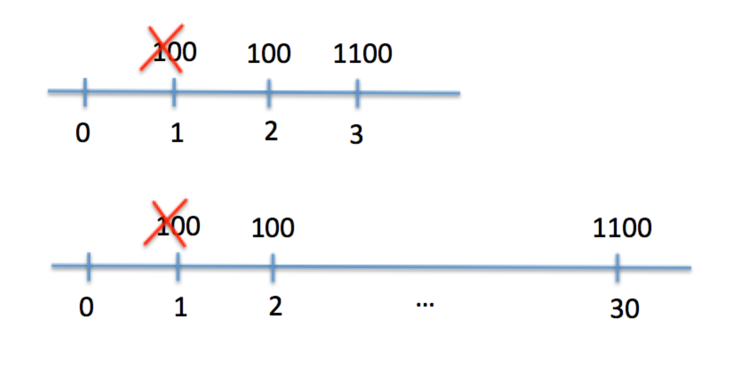

*Both Bond I and Bond II will have a value of $1,000 as long as the market rate stays at 10%. If you know that the rate will go down to 8% next year, then the value of the bond next year after the collection of the second coupon is the present value of the face value discounted 1 year (28 years for Bond II) and the present value of an annuity of 100 that runs for 1 year (28 years for Bond II) calculated at 8%:*

*BVI = 1100/1.08 = 1,019*

*BVII = (100/0.08)(1-1/1.0828) + 1000/1.0828 = 1,117*

*Then, if I sell Bond I and buy Bond II right now, I will profit more since the value of Bond II will go up by a higher margin.*

*(Remember that this is the exact reasoning behind a flattening or inverted yield curve, when rates are expected to go down, people switch from short term to long term bonds)*

1. If the rest of the market has the same expectations about the rate change,

Would your answer to part (a) change?

How would your expected profit change compared to part (a)?

(No calculation is necessary. Explain your reasoning with a few sentences)

*You would still want to switch to longer term bonds but since the rest of the market will do the same, the price of long term bonds will start to increase, erasing the higher-than-market profit opportunity you had in part (a).*

**12.** **(6 points)** BONEYM Inc. is a startup. It is estimated that the company will not be paying any dividends for the coming 4 years. If the company distributes $3 per share 5 years from today, the growth rate of the dividends will be 2% per year going forward. If, instead the company distributes $2 per share at the 5th year, the growth rate of dividends will be 6% per year. As an investor of BONEYM, which policy would you support if the market rate is 12%?

*Stock price at t=0 , [3/(0.12-.02)] / 1.124 = 19.07, if $3 is the dividend in year 5.*

*Stock price at t=0 , [2/(0.12-.06)] / 1.124 = 21.18 , if $2 is the dividend in year 5.*

*You will lose $1 due to reduced dividend in year 5 but the increase in price today offsets that loss. Decision: $2 dividend should be supported.*

**13. (7 points)** The Cengelkoy Cheese Company recently installed a new storage system. The initial cost is $2,000 that will be depreciated on a straight-line basis to a zero-salvage in 5 years. The fixed cost per year is $1,800 and the variable cost is $0.50 per unit. The selling price per unit is $2. Cengelkoy’s tax rate is 34%. If the interest rate goes up from 12% to 15%, how many more units does Cengelkoy needs to sell to be able to financially break even compared to the initial financial break-even point?

*(Graders: please do not take off any points for different rounding conventions, i.e., using two digits, one digit, or rounding to a whole number)*

*Financial break-even when interest is 12% :*   
*EAC = $2,000*0.12/(1-1/(1.125)) = $554.82*

*(EAC+Fixed Costs)*(1-t) – t*Depr.) / (Sales Price-Var. Cost)*(1-t)  
= [$554.82 + $1,800(1 - .34) - $400(.34)] / [($2 - $0.50)(1 - .34)] = 1,623 units*

*Financial break-even when interest is 15% :*   
*EAC = $2,000*0.15/(1-1/(1.155)) = $596.63*

*(EAC+Fixed Costs)*(1-t) – t*Depr.) / (Sales Price-Var. Cost)*(1-t)  
= [$596.63 + $1,800(1 - .34) - $400(.34)] / [($2 - $0.50)(1 - .34)] = 1,665 units*

*1,665-1,623 = 42*

**14.** **(6 points)** You invested on a portfolio with expected return of 16% and a standard deviation of 22%. Assuming that the returns follow a normal distribution, with what probability your money will lose half of its value or more next year?

*(Graders: please note that most of the points should be given to the method for this question)*

*Losing more than half of invested money corresponds to -50% return or less. This corresponds to the half of the probability of rate being outside of the range of the three standard deviations:*

*16%-22%*3 = -50%*

*The probability is (1-99%)/2 = 0.05%.*

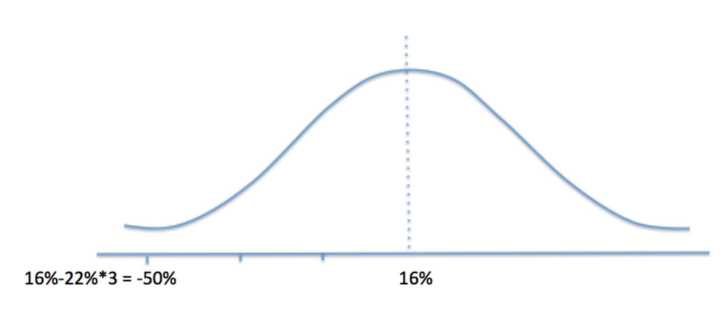

**15.** You have the following information about three mutually exclusive investment opportunities.

|  |  |  |  |
| --- | --- | --- | --- |
| Projects | A | B | C |
| Initial Cost | -10,000 | -8,000 | -9,500 |
| NPV | 1,200 | 1,100 | 750 |
| PI |  |  |  |

1. (5 points) What is the profitability index of each project?

*PIA = 11,200 / 10,000 = 1.12*

*PIB = 9,100 / 8,000 = 1.14*

*PIC = 10,250 / 9,500 = 1.08*

1. (5 points) Which project would you choose using the profitability index criterion?

*Since the projects are mutually exclusive WE CANNOT compare the individual profitability indices. (Graders: If the students compared individual PI, no points should be given for this part. If the student only compared NPVs and not performed the following analysis, NO points should be given for this part.)*

*Lowest initial cost project is B and it is better than investing in the market.*

*Next higher cost project is C and the incremental cost is $1,500 (=9,500-8,000) with the PV of the future incremental cash flow of 1,050 (=10,250-9,100). Therefore, PIC-B = 1,050/1,500 = 0.7. Therefore B is better than C.*

*A has $2000 of incremental cost over B and 2,100 (=11,200-9,100) PV of incremental future cash flow. Then, PIA-B = 2,100/2,000 = 1.05 and A is better than B.*

**16.** You would like to invest on two different bonds: A and B.

A: It has no default risk. Its current price is $958.25. Its will be $942.70 a year from today. It has an annual coupon payment of $80.

B: It is a one-year bond with a promised yield of 12%. It has face value of $1,000, coupon payment of $100 and is expected to pay only $750 at the maturity date in case of default.

1. (6 points) What is the default probability of bond B?

*Bond A has no default risk. Then Its Yield to Maturity (YTM) should be equal to its Current Yield plus its Capital Gains Yield.*

*YTM = Current Yield + Capital Gains Yield*

*YTM = 80/958.25 + (942.70-958.25)/958.25*

*YTM = 8.35%+ (-1.62%)*

*YTM = 6.73%*

*Price of Bond B is 1,100/1.12 = 982.14*

*If the default probability of Bond B is p:*

*982.14(1.0673) = 750p+1100(1-p)*

*p= 15%*

1. (4 points) You invest 30% of your money on A and 70% on B today. What is the expected return (for one year) on your investment?

*6.73%, this is the expected return on Bond A and Bond B. Therefore, any combination of A and B will produce an expected return of 6.73%.*

**17.** Consider two stocks, A and B, with the following characteristics:

|  |  |  |
| --- | --- | --- |
| Stock | Expected Return(%) | Standard  Devation(%) |
| A | 9 | 22 |
| B | 15 | 45 |

The covariance between the returns of A and B is 0.001.

1. (7 points) You would like to invest your money on a portfolio that is formed by A and B. What percentage of your funds should be invested on A if you would like to achieve the lowest possible risk (as it is measured by the standard deviation)?

*σ = xσ + xσ + 2xAxBCov(A,B)*

*σ = x(0.22)2+ (1-xA2)(0.45)2 + 2xA(1-xA )0.001*

*Take the derivative with respect to xA and equate it to 0 to get:*

*xA =.81*

1. (3 points) You would like to keep the same return or obtain higher return on the portfolio you formed in part (a) and reduce the risk level even more. How can you achieve this?

*By forming a new portfolio by combining the above portfolio with an asset that has as low correlation (or covariance) as possible with the portfolio in part a. Negative correlation is preferred to reduce the overall risk.*

**18.** Given the availability of a risk-free asset and all the risky assets in the market, a young investor, Chelsea, calculates the maximum expected return that can be obtained at a standard deviation of 34% as 23%. Risk free asset has an expected return of 3% and the market has a risk premium of 8%.

Company A’s stock has an expected return of 9% and standard deviation 0f 11.2%.

1. What is the correlation between the market and A’s stock?
2. Given that A’s stock has a relatively low return in comparison to the market, why would Chelsea choose to include A’s stock in her portfolio?

23% = xF 3% + xM 11%

23% = (1-xM) 3% + xM 11%

xM = 2.5

xF = -1.5

σP2 = xM2 σM2

34%2 = 2.52 σM2

σM=13.6%

CAPM:

 E(RA) = Rf + SlopeCML(bA)

9%=3%+bA(11%-3%)

bA =.75

Cov(A,M)/ σM2 =.75

Cov(A,M) = 0.1362*0.75 = 1.39%

Corr(A,M) = 0.0139/0.136*0.112 = 0.9107

|  |  |
| --- | --- |
| **Market Value Measures** | Market Capitalization = Price per share * # Shares Outstanding  P/E Ratio = Price Per Share / Earnings Per Share  Market to Book Ratio = Market Value per Share / Book Value per Share  Enterprise Value = Market Capitalization + Market Value of Interest Bearing Debts – Cash  EV Multiple = EV/ EBIDTA |
| **External Financing Formulas** |  |
| **Present Value Formulas** |  |
| **Accounting Ratios** | Current Ratio = Current Assets/ Current Liabilities  Quick Ratio = (Current Assets – Inventory) / Current Liabilities  Cash Ratio = Cash / Current Liabilities  Total Debt Ratio = (Total Assets – Total Equity ) / Total Assets  Debt/Equity = Total Debt / Total Equities  Equity Multiplier = Total Assets / Total Equity  Times Interest Earned = (Earnings Before Interest And Taxes) / Interest  Cash Coverage = (EBIT + Depreciation + Amortization) / Interest  Inventory Turnover = Cost of Goods Sold / Inventory  Days’ Sales in Inventory = 365 / (Inventory Turnover)  Receivables Turnover = Sales / Accounts Receivable  Days’ Sales in Receivables = 365 / Receivables Turnover  Total Asset Turnover = Sales /Total Assets  Profit Margin = Net Income / Sales  Return on Assets = Net Income / Total Assets  Return on Equity = Net Income / Total Equity  EBITDA Margin = EBITDA / Sales  Capital Intensity = Total Assets / Sales |
| **Break Even Point** | Accounting: (Fixed Costs+Depr.)/(Sales Price-Variable Cost)  Financial(Pres. Value): (EAC+Fixed Costs*(1-t) – t*Depr.) / ((Sales Price-Var. Cost)*(1-t)) |
| **Bond Value** |  |
| **Stock Valuation** | Zero Growth: Constant Growth: Differential Growth: |
| **Stock Returns** | Holding Period Return: Arithmetic Average Return: |
| **Sample Statistics** | Corr(A,B) = $ρ_{A,B}= \frac{σ_{A,B}}{σ_{A}σ_{B}}$ |
| **Portfolio Analysis** | Expected Return on Portfolio:    Variance of a portfolio: |